**Mahesh Kumar Uppu**

**700741747**

**Q1**

1. Use a python code to display the following star pattern using the for loop

**Solution**

1. Created a variable number of rows and given the value 5.
2. Used two for loops and range to print first half of the pattern, given numbers of rows and parameter.
3. Then given a * symbol to print.
4. Used another two for loops and range to print the second half of the pattern.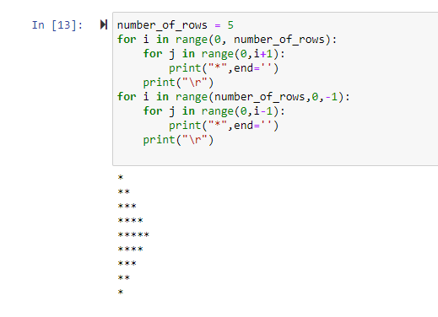

**Q2**

2. Use looping to output the elements from a provided list present at odd indexes. my_list = [10, 20, 30, 40, 50, 60, 70, 80, 90, 100]

**Solution**

1. Created a list name “list” with the given values in the question
2. Used for loop to find the odd index and printed the odd indexes

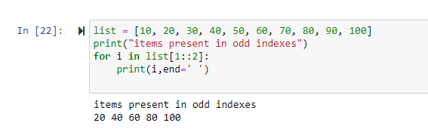

**Q3**

3. Write a code that appends the type of elements from a given list

. Input x = [23, ‘Python’, 23.98]

Expected output [23, 'Python', 23.98]

**Solution**

1. Created an empty list called ‘output’
2. Used for loop and given range as length of given list.
3. Used append to add the output to the new list.
4. Used type to find the datatype of the value and printed the original string, output list

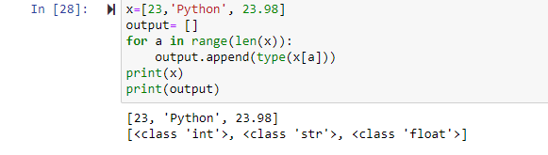

**Q4**

1. Write a function that takes a list and returns a new list with unique items of the first list.

Sample List: [1,2,3,3,3,3,4,5]

Unique List: [1, 2, 3, 4, 5]

**Solution**

1. Defined Sample_List with the given data, created an empty list called uniquelist.
2. Created ulist function and passed Sample_List as parameter
3. Used for loop, if statement to fingd the unique elements and appended to the new list
4. Printed the unique list.

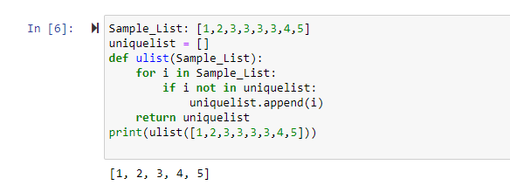

**Q5**

5. Write a function that accepts a string and calculate the number of upper-case letters and lower-case letters. Input String: 'The quick Brow Fox' Expected Output: No. of Upper-case characters: 3 No. of Lower-case Characters: 12

**Solution**

1. Created a function “uplow” with the input as parameter.
2. Created two variables to get the count of upper case and lower-case letters.
3. Used “Issuper” and “Islower” functions to find the upper case and lower-case letters
4. Passed the input
5. Print the count of upper case and lower-case letters

